
Reducing Homelessness Promoting Independence

Esther Community Newsletter
June 2016

Welcome to the Esther Community Newsletter, where we have many exciting new stories and updates to share with you…

Acknowledgements

As Esther is a charitable not for profit organisation, we rely heavily on donations, in order to enable our clients to enjoy all the many activities and celebrations that many of us take for granted. Last year we were particularly blessed to receive many wonderful contributions from a wide spread sector of the Community, such as local churches, schools, food associations and members of the public. We would particularly like to thank:

- Rosemary Lane Chapel
- St Michael’s C of E School
- Newton Poppleford Mothers Union
- South Street Baptist Church
- The United Benefice of St Mark, St Sidwell and St Matthew Churches

- Exeter Food Association
- The Mulberry Tree Cafe
- Dr Snowden
- Christine Davison

Their continued support has enabled us to ensure that our clients receive a range of toiletries when they first come into the Esther Community, are able to choose from a selection of donated clothing and are given fresh fruit and vegetables, to ensure that they eat healthily.
Our clients were overwhelmed at the generosity of the local Community last Christmas, as we were able to give each resident a Christmas stocking that was full of presents, as well as providing a sumptuous Christmas lunch and evening buffet. There was also plenty of food left over for Boxing Day and New Years Day too.
The generosity of kind members of the public never ceases to astound us and so far this year we have received crockery, kitchen equipment, bedding and a large selection of food from various sources.
If you are in a position to be able to donate items i.e. food, clothes or other useful items, we would love to hear from you. Please feel free to contact the office in order to arrange delivery. We are also extremely grateful if you are in a position to be able to offer a monetary donation, however big or small. This can be used on such things as group activities or essential items for those staying at Esther.

New Team Members

Since our last newsletter, we have been extremely fortunate to welcome four new members to our fabulous staff team here at Esther. We have employed three new bank staff, Sara, Sam and Rachel and a new night team member, Shaun, who together bring a wealth of new experiences and knowledge to the team.

Introducing…. Shaun

Shaun has been with us since January 2016, after working at the Atkinson Unit in Exeter for the past 8 years. Although he thoroughly enjoyed his role there, he felt it was time for a change and was eager to take on a new challenge.
Shaun was born in Clapham, 43 years ago, to a Ugandan mother and a Jamaican father. He has four siblings; two brothers and two sisters, who he is very close to. He had a colourful upbringing, where music and large family gatherings played a big part in his childhood. He sang in the church choir every Sunday, where to his great amusement he discovered that the name of his choir master was James Jim Jelly, who was a great source of inspiration to him. He was, however, a naughty child who was constantly in trouble with his school teachers. Due to lack of focus, he failed his GSCE’s on the first attempt, but later went on to pass them with flying colours. He was unsure of which career path to take, but knew that he didn’t wish to continue with further education. His numerous job roles from then on included working as a labourer, a Security Guard and a doorman at a nightclub. But until his brother, who was a graphic designer, recommended a position as an intern at Just Seventeen Magazine, he struggled to commit to any career. It was whilst working at the magazine that he discovered his love of writing and began to channel his energy into becoming a journalist.
Shaun moved on to various other magazines, where he continued his internships and even had an article published for Sky Sports magazine. Despite receiving accolades for his work, he was becoming increasingly disillusioned with living in London at this time.
He began looking further afield for job roles and soon secured a position working with young people in Devon, for a group called CSV (Community Service Volunteers), where he mentored them and taught them independent living skills.
After this project unfortunately closed, he worked at the Wilder Park Project, which was a very similar organisation to Esther. He also worked at the Atkinson Unit, before finally arriving here at Esther. Shaun has fitted seamlessly into the team and his enthusiasm and commitment has had a positive impact on the residents and staff alike.
When asked what his ultimate goal was, he said that he would like to be a good Dad, a good friend, a good human being and the best version of himself he could be.



DAISI Urban Music Project Update

The Urban Music Project, funded by DAISI, that proved so successful with our clients last year, has once again been running to full capacity here at Esther. DAISI is a National Charity which funds music making for young people in challenging circumstances. The project was initially run for a six week trial period, but due to the overwhelming interest from our clients, we were thrilled to welcome them back for another series of workshops.
The reason for its success is due in no small part to the commitment and enthusiasm of its coordinator, Mike Cook. He is a 28 year old music impresario, whose full and varied career incorporates qualifying as a teacher in Radio Production and Music Technology, working with visually impaired students at the West of England School and College and becoming Project Manager at CEDA (Community, Equality, Disability, Action), where he coordinated music access for young people with disabilities.
The workshops run for six weeks and consist of one 2 hour session per week. Mike brings with him all the equipment necessary for creating digital music, such as a laptop, speakers, microphone and a set of digital decks. Mike sets up open access and 121 targeting sessions and leads on the client’s interests, or guides them towards areas he thinks would be of particular enjoyment to them.
Some of our clients became involved in producing their own CD of rap or drum and bass music, while others were able to express themselves through singing, song writing and recording. Whatever format their musical preference may take, each young person has the opportunity to work in a productive environment, which enables them to feel fulfilled, whilst raising their confidence and self-esteem and expanding their knowledge of music. It also allows them to create a product that they can keep forever.

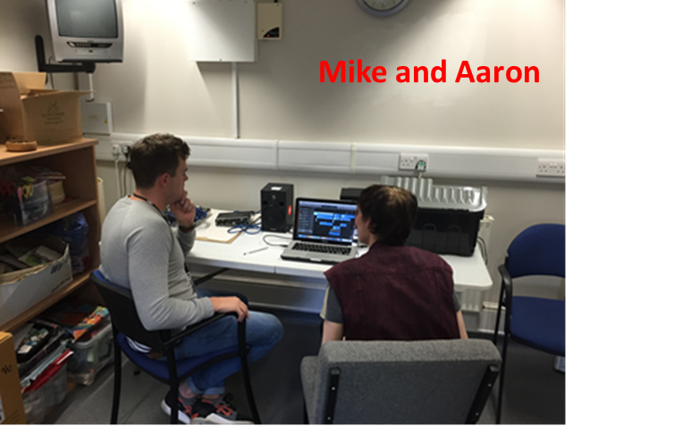

Radio One Million Hours Campaign

We were recently invited to take part in the BBC Radio One Million Hours Campaign, which was set up so that people across England and Wales could pledge a million hours worth of volunteering. A member of our staff team, together with one of our residents, was invited to attend one of five academy days that were set up at Exeter Phoenix Art Centre. As well as being given the opportunity to recruit volunteers, they also joined in workshops designed to equip young people with the skills needed to gain employment in the Media industry. Workshops consisted of music production, CV writing for the music profession, music management and how Social media plays an integral part in the music Industry. Both staff and resident alike found the experience very enlightening, educational and informative.
We were also delighted to be given four tickets for the Radio One Big Weekend, which were raffled off so that everyone had a fair chance of winning.
We hope that as a result of this campaign, we will be given the opportunity to welcome many new volunteers to Esther.


Volunteer Handyperson

Due to funding cuts in 2014, the role of handyperson was unfortunately made redundant. We tried to carry out necessary repair work ourselves, but due to time constraints and lack of skills and knowledge in that field, parts of the hostel were in dire need of maintenance and repair. Just as we

were becoming slightly overwhelmed at all the jobs that needed carrying out, along came a knight in shining armour in the form of our Manager’s husband, Stu! Although he is in employment as a caretaker at a local school, he offered his services as a volunteer handyperson in his spare time. Stu has proved invaluable in bringing Esther Community back to its former glory and has painted and wallpapered rooms, replaced broken taps, fixed leaks and completely renovated one of our four flats. As well as being adept at repairs and maintenance, he has also been an inspiration to several of our young clients, who, having chatted to Stu and watched him at work, have decided that they would like to take up an apprenticeship in a similar field themselves. Indeed, one of our residents has really come out of his shell since meeting Stu and is not only gradually overcoming his shyness, but is also gaining in confidence since working alongside Stu on many of his tasks.
Stu has a vibrant, fun personality and nothing is too much trouble for him. We, at Esther, are surprised that he has any spare time left in his busy schedule, with three growing daughters to look after, not to mention being married to the dynamic lady at the helm of the Esther Community.
Stu says that he gets great satisfaction from transforming rooms and helping our clients and all he asks in return is a cup of coffee and a smile!

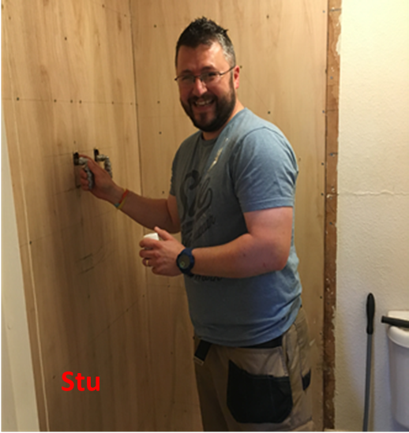
Follow up on Jordan

Since our last newsletter, Jordan has continued to grow. He has moved across to one of our four bedsits, which offer more independence and the opportunity to take responsibility for paying his own bills, working in collaboration with the other bedsit residents towards the up keep of communal areas and taking care of his own private quarters. These are all key skills necessary for independent living.
Jordan has just finished his second year at college and is currently waiting to see if he has gained his NVQ/VRQ Level 2 qualification in Hospitality and Catering. If he is successful, he will continue on to complete his NVQ/VRQ Level 3 in Catering. Now that he has his own kitchen, he is able to refine his culinary skills and is particularly pleased with a recipe for Chicken and Bacon Risotto that he created himself. He tries to eat healthily and regularly cooks dishes such as pork stir fry, pasta, stuffed peppers and other recipes acquired from his college course.
Jordan has also gained in confidence and has made many new friends at Esther and at college, some of whom he also meets up with socially.
Jordan is currently seeking part time employment, as college has ended for the summer and he likes to keep himself occupied.
Indubitably the additional money will also prove useful in paying for driving lessons and the theory test, which he has so far entirely funded himself, through clever budgeting and cutting costs where necessary.
Jordan still has the same goals and aspirations, although his increase in confidence and self assurance has enabled him to refine his ideal job role to that of Front of House in a restaurant, rather than working in the kitchen. He feels that this is where his true vocation lies.
He is gradually working towards living independently from Esther and is one of our many success stories. When Jordan does eventually move on, he will leave behind a team of very proud staff members.
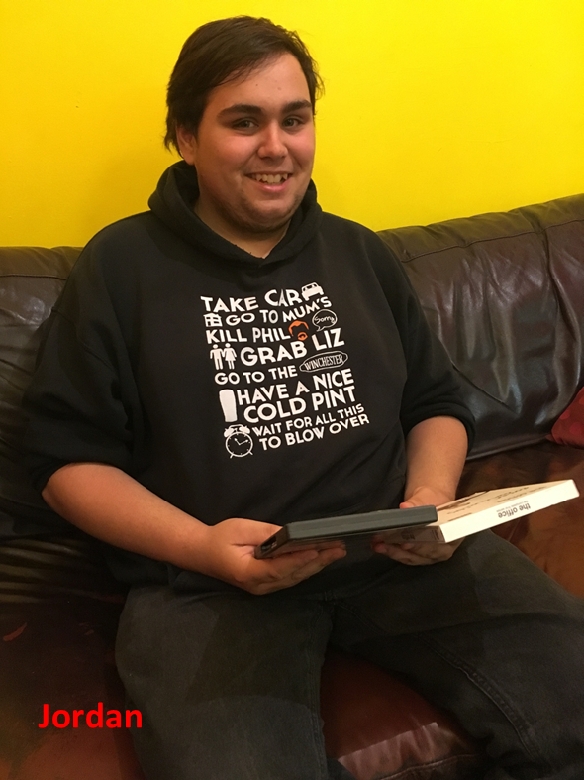

Prayer of Thanksgiving
Our Heavenly Father,
We thank you for all good gifts
We thank you for sending us your son,
To show us the Way, the Truth and the Life.
We ask that you help us to show wisdom, compassion and kindness, to the precious young people whom we seek to help.
And when we lack the answers or the wisdom, teach us to ask for your help, Amen

Esther Contact Details:

Manager: Rebecca Chaplin
Office tel no: 01392 496600
Fax: 01392 421509

Website: www.esthercommunity.org.uk
Email: esthercommunity@keychange.org.uk

Newsletter Editor: Adrienne Hennessey

Assistant Newsletter Editor: Jordan Flowers

The Esther Community is part of Keychange Charity and is a registered charity, No 1061344; a company limited by guarantee, No 3317563 (England) and is affiliated to the Evangelical Alliance

